Software Design Document(SDD)
Project Title: Mobile Sales Management System
(Tech wave)


Submitted by:
Muhammad Numan
Roll No:
S25BINFT7M04016
Semester:
7th(1M)
Submitted to:
Prof:Abdul karim nawaz

Department of Information Technology
Faculty of Computing
The Islamia University of Bahawalpur

Summery
The Mobile Sales Management System (Tech Wave) is a web-based application developed to automate and simplify the process of mobile phone sales and management. The system provides an efficient platform where customers can browse mobile products, search and filter products, add items to a shopping cart, and place orders online. It eliminates many of the limitations of manual sales management by offering a centralized and user-friendly digital solution.
The system consists of two main users: Customers and Administrators. Customers can register, log in, view available mobile phones, manage their shopping carts, and track their orders. Administrators have access to a dedicated dashboard that allows them to manage products, customers, orders, and system records efficiently.
The application is developed using HTML, CSS, JavaScript, PHP, and MySQL, following a three-tier architecture consisting of the Presentation Layer, Application Layer, and Database Layer. This architecture ensures better maintainability, scalability, and performance of the system.
The project aims to improve sales management by providing faster product access, secure user authentication, accurate order processing, and efficient database management. Security measures such as password encryption, input validation, and role-based access control are implemented to protect user information and system resources.
Overall, the Mobile Sales Management System provides a modern, reliable, and scalable solution for managing mobile phone sales while enhancing customer experience and improving administrative efficiency.

TABLE OF CONTENTS
Section No. | Description
1 | Introduction
2 | System Architecture
3 | System Modules
4 | Database Design
5 | User Interface Design
6 | Process Design
7 | Security Design
8 | Performance Design
9 | Testing Strategy
10 | Conclusion

SOFTWARE DESIGN DOCUMENT (SDD)

Project Title:
Mobile Sales Management System (Tech Wave)

Prepared By:
Muhammad Numan
Roll No: S25BINFT7M04016

1. Introduction

1.1 Purpose
The purpose of this Software Design Document (SDD) is to describe the architecture, design components, database structure, user interface design, and implementation details of the Mobile Sales Management System (Tech Wave).
This document provides technical guidance for developers, testers, and stakeholders involved in the development of the system.

1.2 System Overview
The Mobile Sales Management System is a web-based application designed to facilitate the buying and selling of mobile phones. Customers can create accounts, browse products, search for mobile devices, add products to a cart, and place orders.Administrators manage products, customers, and orders through a centralized dashboard.
2. System Architecture

2.1 Architectural Design
The system follows a Three-Tier Architecture:

Presentation Layer (Frontend)
Responsible for user interaction.
- Components:
- HTML
- CSS
- JavaScript
Functions:
- Display products
- User registration
- Login forms
- Shopping cart interface
- Admin dashboard

Application Layer (Backend)
Responsible for business logic.
Technology:
- PHP
Functions:
- User authentication
- Product management
- Cart processing
- Order processing
- Data validation

Data Layer
Responsible for data storage.
Technology:
- MySQL Database
Functions:
- Store customer information
- Store product records
- Store order information
- Maintain system data 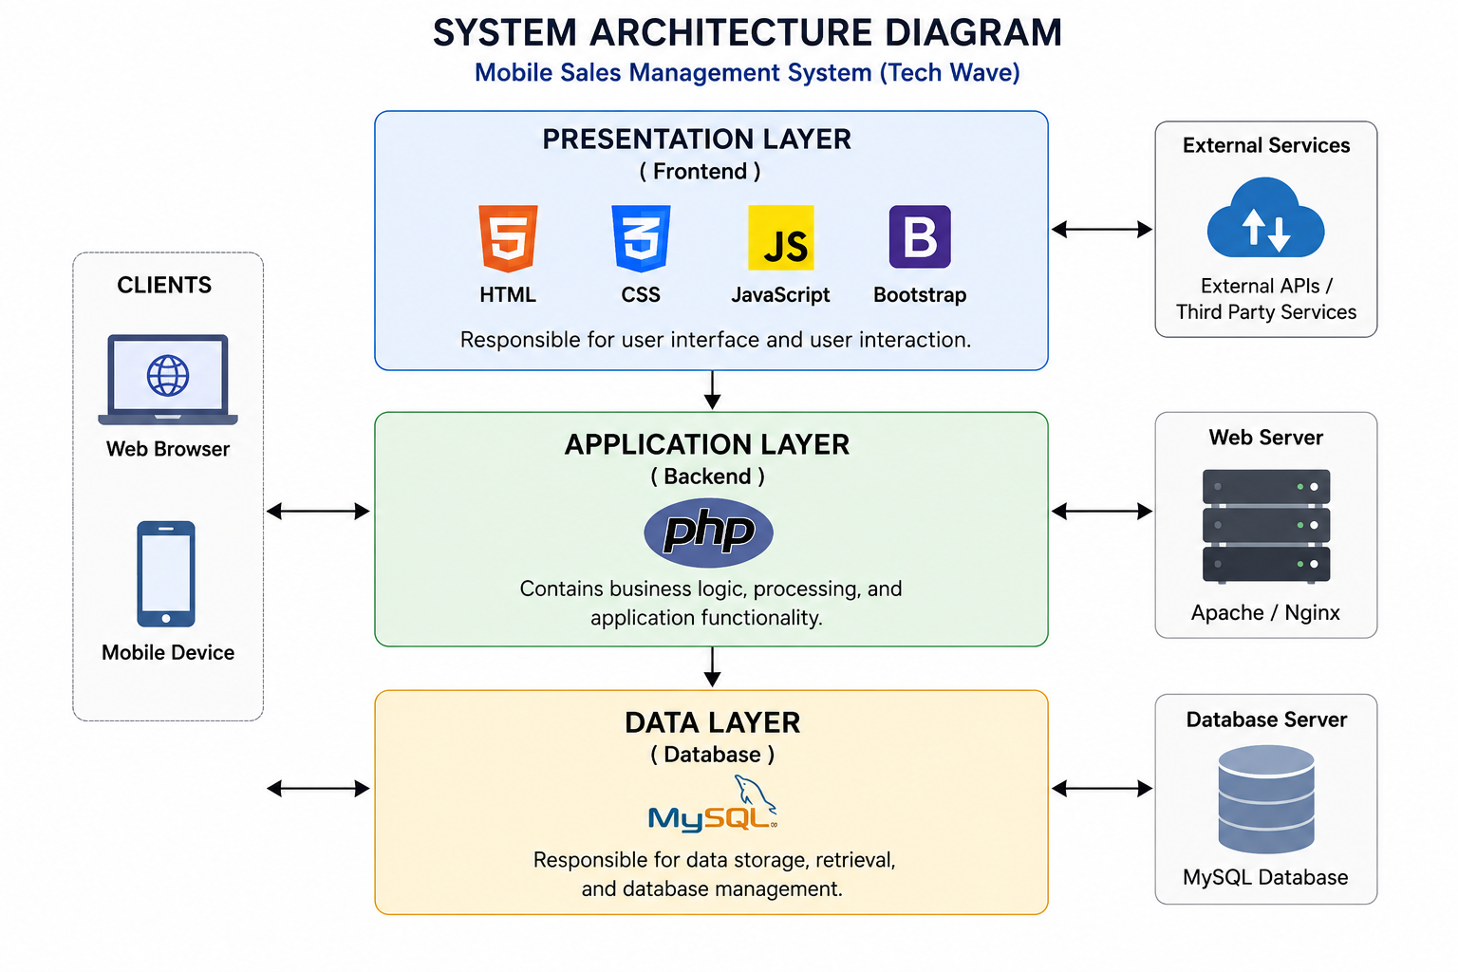

3. System Modules
The application is divided into the following modules:

3.1 User Management Module

Description
Handles registration, login, and account management.

Features
- User registration
- User login
- Password validation
- Session management

Inputs
- Name
- Email
- Phone Number
- Password

Outputs
- Account Creation Success
- Login Success/Failure

3.2 Product Management Module

Description
Allows the admin to manage mobile products.

Features
- Add Product
- Update Product
- Delete Product
- View Product List

Product Information
- Product ID
- Mobile Name
- Brand
- Price
- Description
- Image

3.3 Product Browsing Module

Description
Allows customers to view available mobile phones.

Features
- Display product catalog
- Product details page
- Product comparison

Outputs
- Product Information
- Product Images
- Pricing Details

3.4 Search and Filter Module

Description
Allows users to quickly find products.

Features
- Search by keyword
- Filter by brand
- Filter by price range

Benefits
- Faster navigation
- Better user experience

3.5 Shopping Cart Module

Description
Temporarily stores selected products before order confirmation.

Features
- Add product to cart
- Remove product
- Update quantity
- View cart summary

Outputs
- Total Amount
- Selected Products

3.6 Order Management Module

Description
Handles order placement and tracking.

Features
Customer Side:
- Place Order
- View Order History
Admin Side:
- View Orders
- Update Order Status
- Manage Deliveries

Order Status
- Pending
- Confirmed
- Processing
- Completed
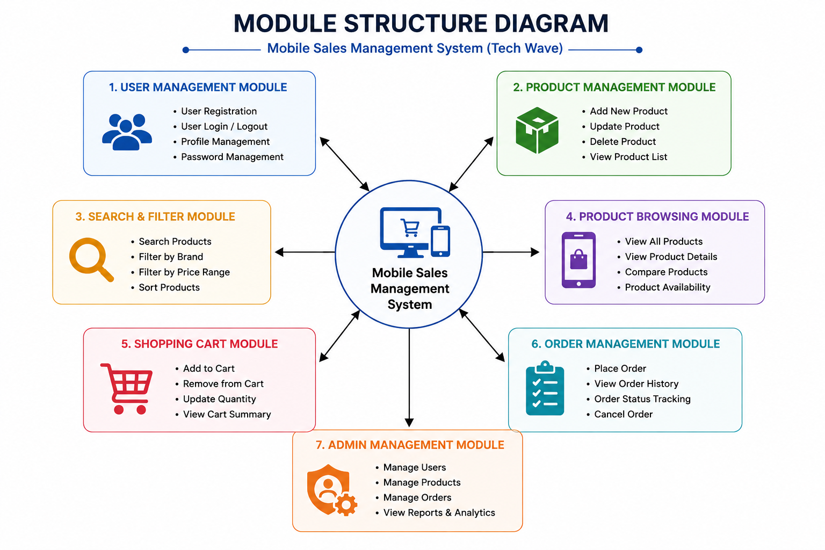

4. Database Design

4.1 Database Overview
The system uses MySQL as the database management system.

Main Tables
- Users
- Products
- Cart
- Orders
- Order Details

4.2 Users Table
Field Name | Data Type
UserID | INT (PK)
Name | VARCHAR(100)
Email | VARCHAR(100)
Phone | VARCHAR(20)
Password | VARCHAR(255)
Role | VARCHAR(20)

4.3 Products Table
Field Name | Data Type
ProductID | INT (PK)
ProductName | VARCHAR(100)
Brand | VARCHAR(50)
Price | DECIMAL
Description | TEXT
Image | VARCHAR(255)

4.4 Orders Table
Field Name | Data Type
OrderID | INT (PK)
UserID | INT (FK)
OrderDate | DATE
TotalAmount | DECIMAL
Status | VARCHAR(50)

4.5 Order Details Table
Field Name | Data Type
DetailID | INT (PK)
OrderID | INT (FK)
ProductID | INT (FK)
Quantity | INT
Price | DECIMAL

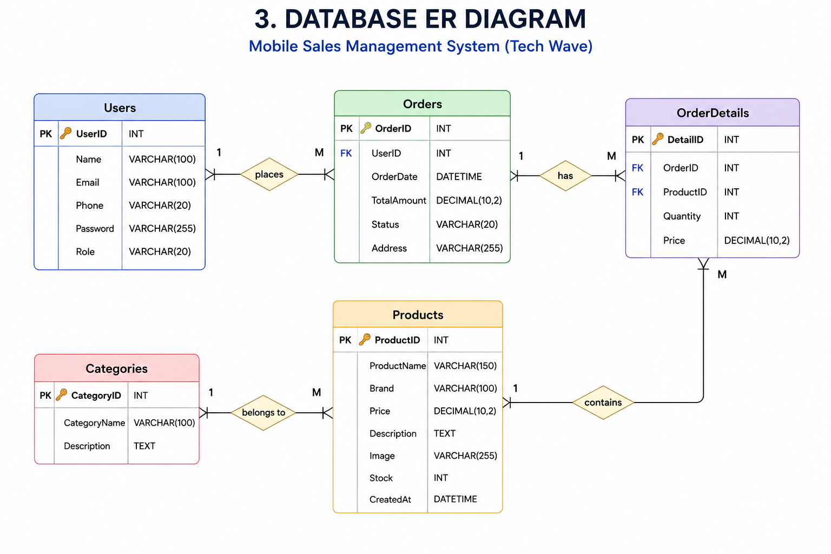

5. User Interface Design

5.1 Home Page

Components
- Navigation Bar
- Featured Products
- Search Bar
- Product Categories
- Footer

Purpose
Provides entry point to the system.

5.2 Registration Page

Fields
- Full Name
- Email
- Phone Number
- Password
- Confirm Password

Buttons
- Register
- Reset

5.3 Login Page

Fields
- Email
- Password

Buttons
- Login
- Forgot Password

5.4 Product Page

Display
- Product Image
- Product Name
- Price
- Description
- Add to Cart Button

5.5 Shopping Cart Page

Display
- Product List
- Quantity
- Price
- Total Cost

Actions
- Remove Product
- Update Quantity
- Checkout

5.6 Admin Dashboard

Sections
- Product Management
- User Management
- Order Management
- Reports 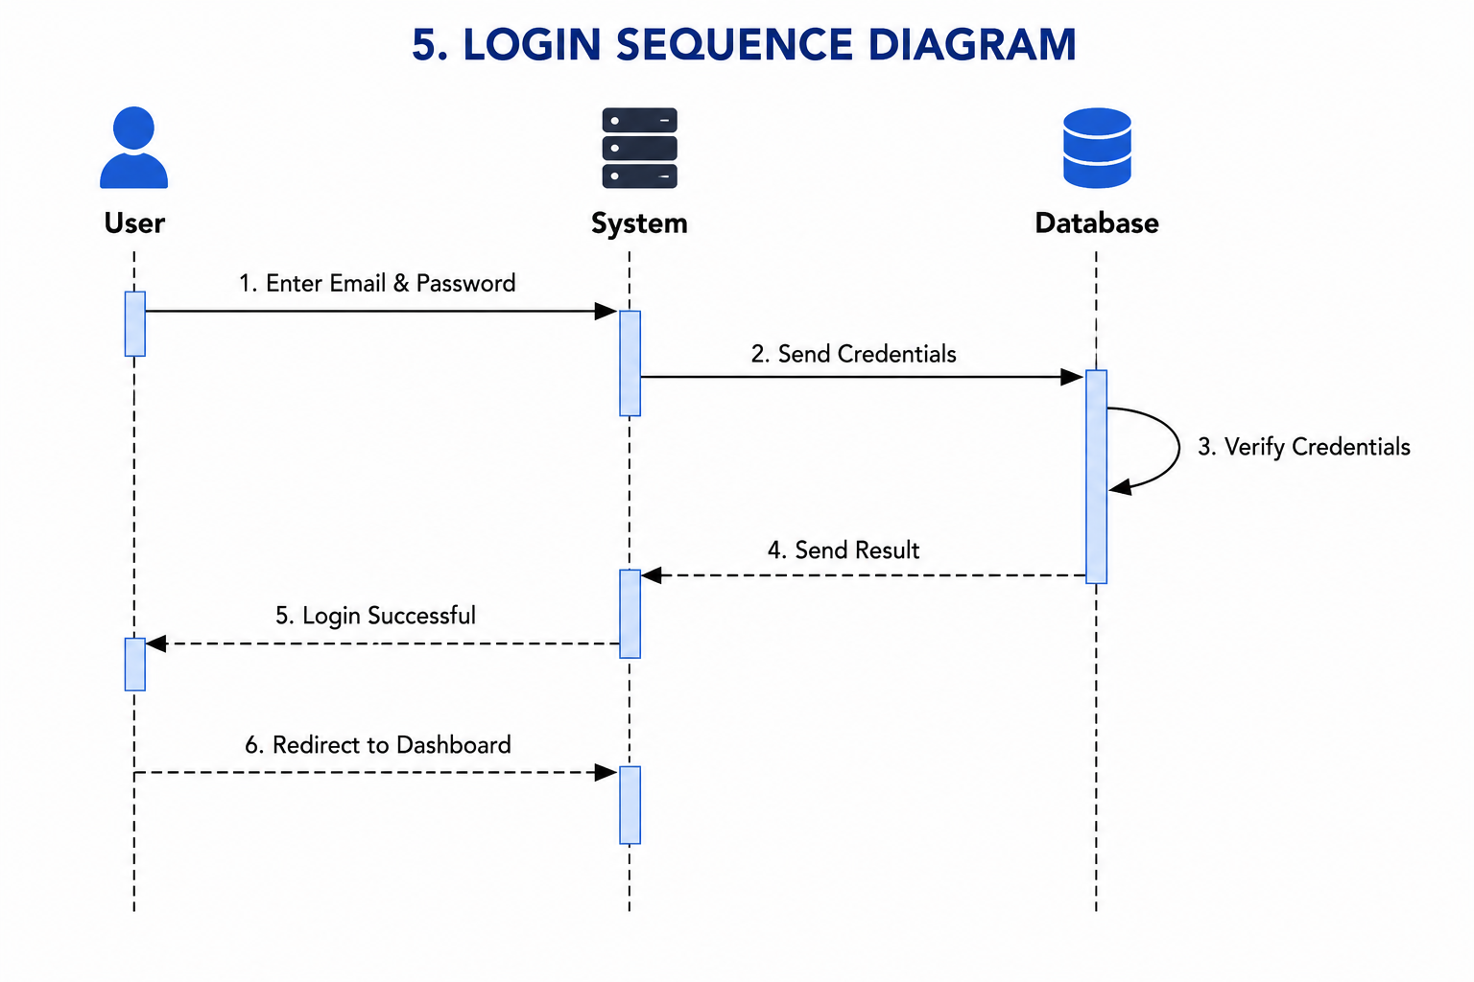

6. Process Design

6.1 User Registration Process
Step 1: User enters registration details.
Step 2: System validates input.
Step 3: Email uniqueness is checked.
Step 4: Password is encrypted.
Step 5: User information is stored in database.
Step 6: Account creation confirmation is displayed.

6.2 Login Process
Step 1: User enters email and password.
Step 2: System validates credentials.
Step 3: Database verification is performed.
Step 4: Session is created.
Step 5: User is redirected to dashboard/homepage.

6.3 Order Placement Process
Step 1: Customer adds products to cart.
Step 2: Customer reviews cart.
Step 3: Customer confirms order.
Step 4: System generates Order ID.
Step 5: Order is stored in database.
Step 6: Confirmation message is displayed.
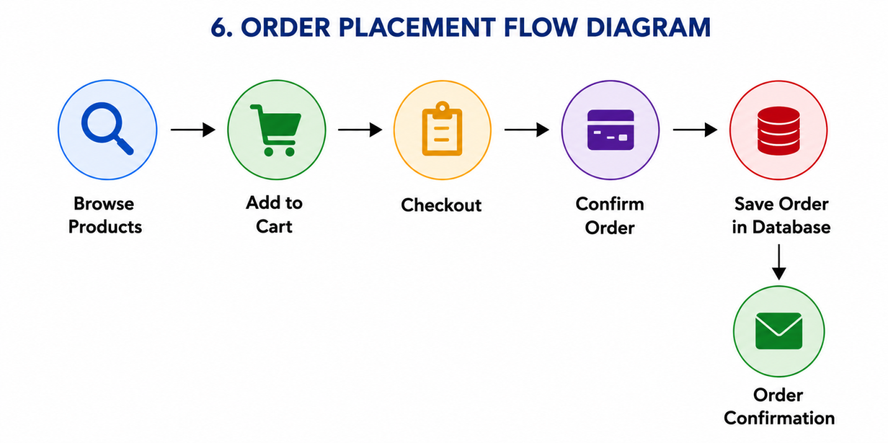

7. Security Design

7.1 Authentication
- Secure login mechanism
- Session-based authentication
- User role verification

7.2 Password Security
- Password hashing
- Encrypted storage

7.3 Data Validation
- Input validation
- SQL Injection prevention
- Form validation

7.4 Access Control
Admin Access:
- Product management
- Order management
Customer Access:
- Product browsing
- Cart management
- Order placement

8. Performance Design

Response Time:
The system should respond within 3 seconds under normal conditions.

Optimization Techniques:
- Indexed database tables
- Optimized SQL queries
- Efficient page loading

Scalability
The system should support future enhancements such as:
- Online payment integration
- Delivery tracking
- Multi-vendor functionality

9. Testing Strategy

Unit Testing
Tests individual modules.
Examples:
- Registration validation
- Login validation
- Product insertion

Integration Testing
Tests interaction between modules.
Examples:
- Cart and Order Module
- Login and Dashboard Module

System Testing
Tests complete application workflow.
Examples:
- User Registration to Order Placement

User Acceptance Testing (UAT)
Performed by project supervisor and end users to verify requirements.

10. Conclusion
The Mobile Sales Management System (Tech Wave) provides a complete solution for managing mobile phone sales digitally. The design follows a three-tier architecture using HTML, CSS, JavaScript, PHP, and MySQL. The system supports customer registration, product browsing, shopping cart management, order processing, and administrative control.
The proposed design ensures security, maintainability, usability, and future scalability while fulfilling all functional and non-functional requirements specified in the Software Requirement Specification (SRS

